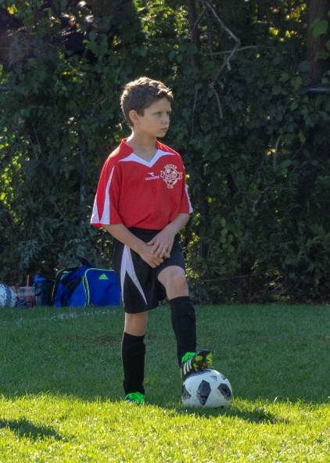 Images of Greyson Playing Soccer- September 29, 2018

On Saturday, the 29th, we traveled down to Leominster, MA, to see grandson Greyson play another game of organized soccer. This year Grey is in 4th grade and in a 3-4 grade Stow team competing with various area town teams in the Massachusetts Nashoba Valley Youth Soccer League.

Today’s game was against the Leominster team. Grey’s team secured a 3-0 victory – to continue their undefeated season.

And for the photos, click [Greyson – Soccer/2018](https://photos.app.goo.gl/mBnTQk8Uv2TMuRWp8).